
CASE STUDY
Magnox Leads The Way In Manual Handling In The Nuclear Decommissioning Industry By Specifying Fibrelite

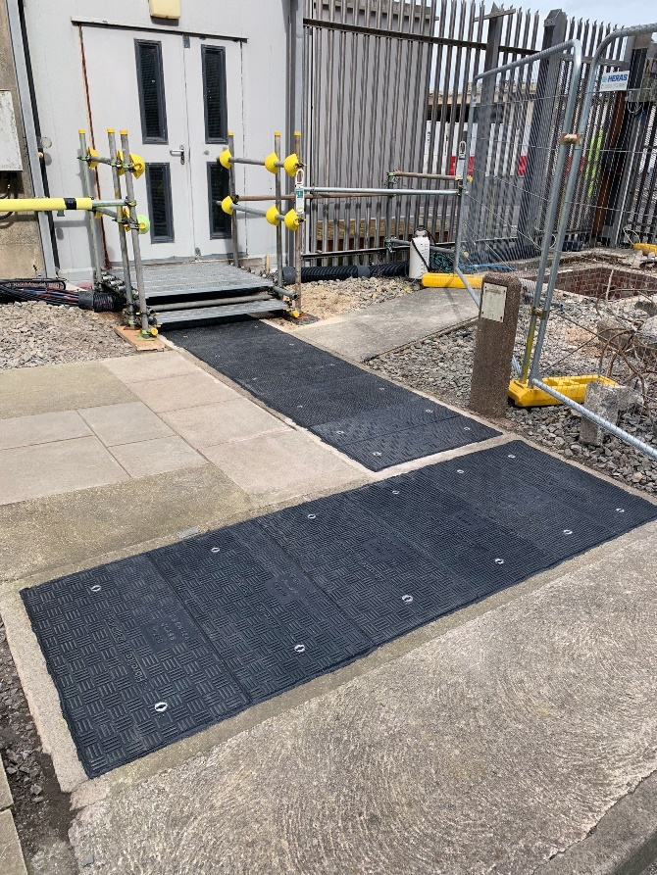
Fibrelite engineered bespoke retrofit GRP trench covers for the Hinkley Point (A) Nuclear Power Station, currently under decommissioning
Fibrelite were approached by Magnox to provide numerous replacement manhole and trench covers to replace the existing degrading concrete and cast-iron covers. This works had to be co-ordinated and delivered within a tight schedule to provide a safe, efficient and consistent solution within the decommissioning work being undertaken at Hinkley Point A.
Key features of Fibrelite covers for this project:
- Best strength to weight ratio available in the market today
- Fully customisable options available as standard
- Reliable – cover load ratings consistent with the requirements of EN 124
- Easy interface – no specialist personnel or machinery required for maintenance/operation post install

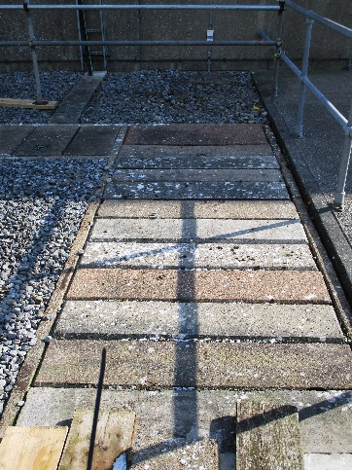  Previously installed concrete trench access covers had begun to corrode | 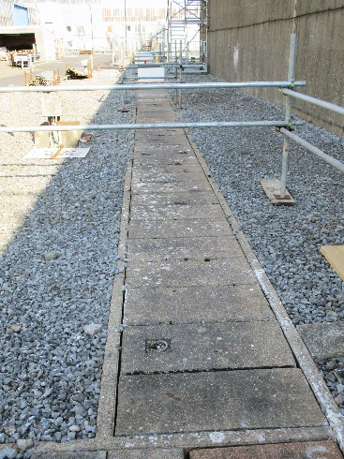  Exclusion zones were put in place to prevent loading causing a failure of the covers during the decommissioning work | 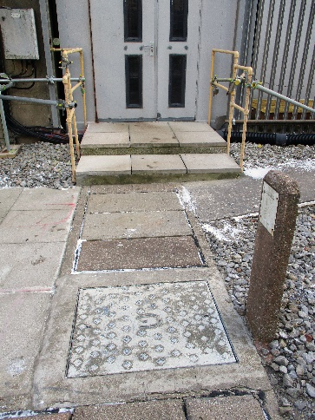  The load capacity of the concrete covers was unknown and thus unreliable
Problem
The client established that the pre-existing concrete covering arrangement would be very troublesome long term and had experienced a number of failures across a number of locations/sites causing confidence in these access covers to be questioned. Typically, the existing covers are located in pedestrian and vehicular traffic areas. This lack of confidence had led to large areas being barriered off and exclusion zones put in place. The existing cover material poses a number of difficulties:
- Extreme weight – particularly in the nuclear industry, ease of access for services is imperative. Heavy concrete covers impair this
- Manual handling – the customer was concerned about the risk of injury due to the manual handling of these heavy loads
- Deteriorating performance – the covers were exhibiting high levels of corrosion and structural degradation leading to concerns of fit for purposes application
The size and complexity of this project deemed that the design would need to be very flexible.
Solution
Fibrelite proved to be an ideal choice for the client’s requirements, meeting their demands in a number of areas:
- Lightweight covering arrangement suitable for two-person lift
- Health & safety concerns surrounding manual handling eliminated
- Chemically inert - safe & functional. Uniform ‘anti-slip’ tread pattern supplied as standard, will last for years to come without degradation
Fibrelite provided all fully customisable options to the customer which were essential and unique to the customer. For this project Fibrelite provided differing depths, load ratings and covers with locking mechanisms in some instances.
The nuclear facility now has a safe covering for their utilities during the decommissioning work
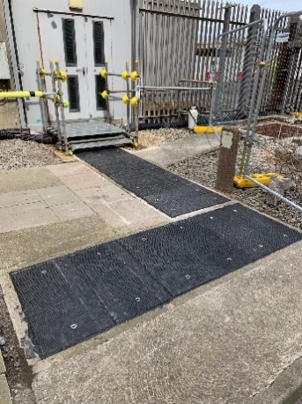 | 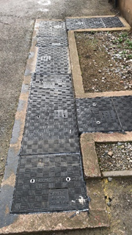 | 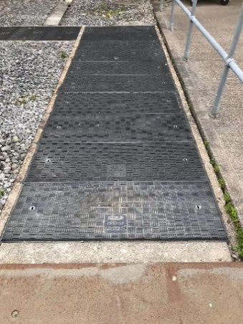
Fibrelite’s lightweight covers can be safely manually removed
Fibrelite covers are chemically inert and have an anti-slip tread pattern
Results
Post install – the customer was pleased with the finish provided and advised they would continue to specify Fibrelite access covers for future projects. Benefits at a glance:
- Chemically inert covers will last for years to come
- Access to trench services simplified using the Fibrelite FL7 ergonomic lifting handles (allowing safe lifting from waist height)
- All bespoke product features adhered to allowing minimal disruption to site
- ‘Fit and forget’ solution - modern, safe & secure
- Trench and manhole covers that have technical data underpinning load capacity and test results
- Significant site hazard reduction

For more case studies, visit the Fibrelite website

