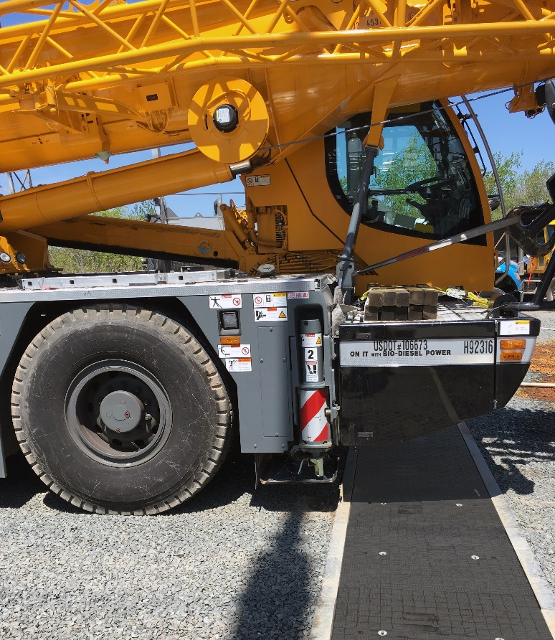
Fibrelite Trenwa Partnership Goes from Strength to Strength
Fibrelite GRP HS20 covers in Trenwa trenches withstand 18 tonne crane trucks during substation rebuild

Since 1960 the composites industry has grown 25X as industry after industry adapt their light, strong hardwearing qualities to create higher performance products than previously possible. The US is leading the charge with the second largest market for composites globally (after China).
Fibrelite has been using composites for many years to re-engineer omnipresent yet little-noticed products: manhole and trench access covers. Traditionally manufactured from metal and concrete, Fibrelite is using glass reinforced plastic composites to solve manual handling injuries and corrosion issues associated with covers made from traditional materials.
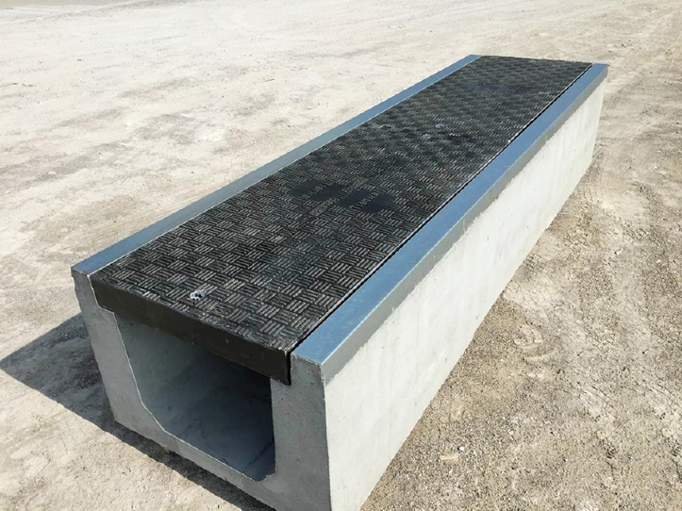
In 2014, Fibrelite and precast concrete trench manufacturer Trenwa formed a strategic partnership to create joint product offerings: Trenwa’s heavy-duty precast concrete road crossing trenches topped with Fibrelite’s traffic rated composite trench covers. Together they provide long-term protection for underground utilities running across road crossings while enabling safe and fast manual access for monitoring and maintenance.
Fibrelite and Trenwa’s partnership product: heavy duty precast concrete trenches topped with light strong composite covers
In the 3 years since the partnership began, Trenwa has sold well over a hundred of their precast trench systems integrating Fibrelite trench covers for use in electrical substations, wastewater treatment plants, chemical refineries and many other applications across North America.
“Combining high-performance, lightweight Fibrelite covers with our low-cost precast trench bases delivers a very high-value solution for our customers. They get unparalleled strength and durability at a lower cost than has ever been seen in the market.”
George Schurr, President/COO, Trenwa Inc.

Trenwa and Fibrelite’s road crossing trench was recently recognized during JEC Group’s (the “largest composites industry organization”) very first edition of the Future of Composites in Construction, where it was a highlight of the “Innovation Hub”.
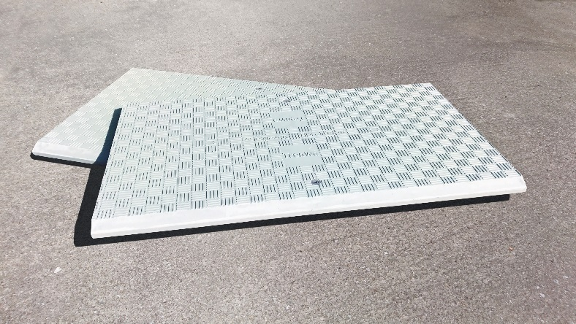
As increasing numbers of people learn about the benefits of using Fibrelite trench covers, many are looking to upgrade previously installed concrete or steel trench covers. To meet this demand, Trenwa have worked with Fibrelite to design and manufacture custom moulded composite trench covers to fit Trenwa’s existing line of precast multi-duty trench systems. These covers are engineered specifically for light vehicle traffic (12.5-tonne load rated) and pedestrian traffic (1.5-tonne load rated) respectively.
New composite trench covers designed for pedestrian traffic (1.5-tonne load rated) to fit Trenwa’s line of multi-duty trench systems
“I am excited to see our partnership with Trenwa growing as their customer base continues to adopt our lightweight, corrosion resistant composite trench covers.”
Jim Goodman, US Key Account Manager, Fibrelite

Recent Project: New Substation for Leading US Utility Provider
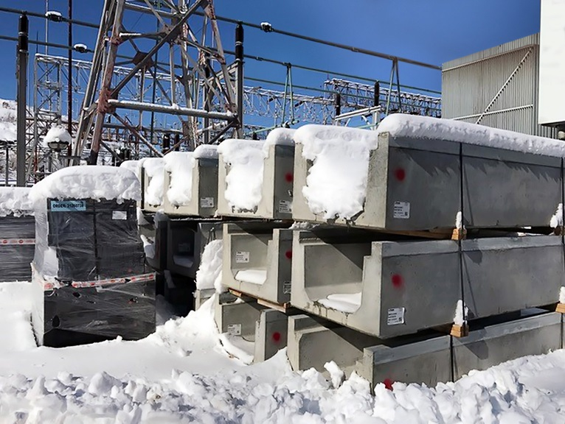
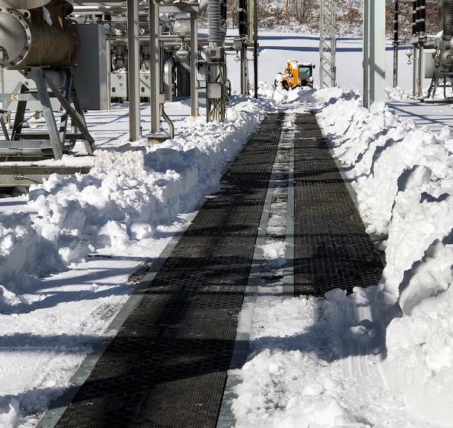
Precast concrete trenches are used extensively on substations to carry and protect the large amounts of electric conduits and cabling required. Where trenches cross access roads, load ratings of HS20 are required to handle heavy-duty vehicles such as cranes. Fibrelite and Trenwa’s joint product provided the perfect solution for this leading US utility provider. (Full case study on the Fibrelite website)
HS20 GRP Fibrelite Covers in Trenwa’s Precast Concrete Trenches
Trenwa’s precast trenches ready for installation

ENDS
Notes for Editor:
Full quality images attached
About Fibrelite
Fibrelite is a global manufacturer of highly-engineered glass reinforced plastic (GRP) composite access covers capable of taking up to 90 tonne loads whilst still being light enough to be lifted by hand and is renowned for its high quality technical support and service.

Initially developed 37 years ago and now industry standard for petrol station forecourts, Fibrelite covers are increasingly specified for both new and retrofit work in a variety of industries in more than 80 countries around the world. To find out more, please visit www.fibrelite.com.

For more information, please contact Joe Stott (jostott@fibrelite.com 01756799773)
Fibrelite; Snaygill Industrial Estate; Keighley Road; Skipton; North Yorkshire BD23 2QR

Composites Manufacturing magazine website, Published January 2017, http://compositesmanufacturingmagazine.com/2017/01/composites-industry-report-2017/
Composites Lab by ACMA website, http://compositeslab.com/composites-101/composites-industry-overview/

