Growing Trend: UK Redevelopment Programmes Replace Concrete Recess Covers with Safer GRP Composite Alternatives

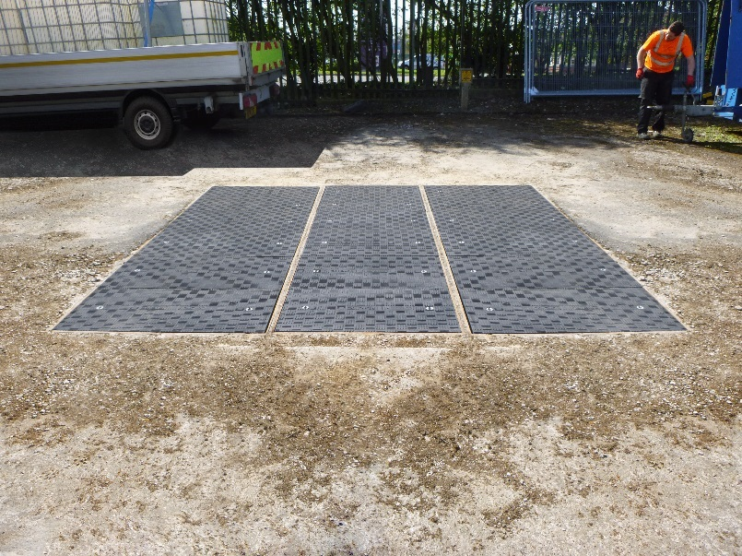
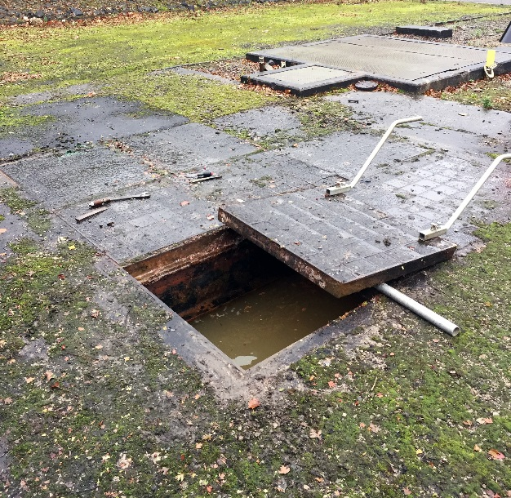
This year, UK manufacturer Fibrelite has seen a growing trend of a wide range of facilities choosing to upgrade from the concrete recess access covers traditionally used in favour of bespoke composite alternatives.
Cadent Gas facility before and after the Fibrelite upgrade

According to Fibrelite, the primary drivers of this change are initiatives around reducing manual handling risks and increasing efficiency, together with increased industry knowledge of GRP composite products.
This trend has been observed in a diverse range of industries including utilities, water, ports, power and substations, stadiums, tunnels, airports and many more. Fibrelite has seen their covers increasingly specified for both new and retrofit work in a variety of industries in over 80 countries. A recent example is Lindley Oil Refinery, who specified Fibrelite’s GRP trench covers as part of a large-scale renovation project.
Concrete Recess Access Covers
The concrete recess covers conventionally used are very heavy, especially at high load ratings, posing manual handling risks for operators while time consuming to remove and replace, often requiring expensive specialised lifting apparatus. The surface can also cause slip hazards for pedestrians.
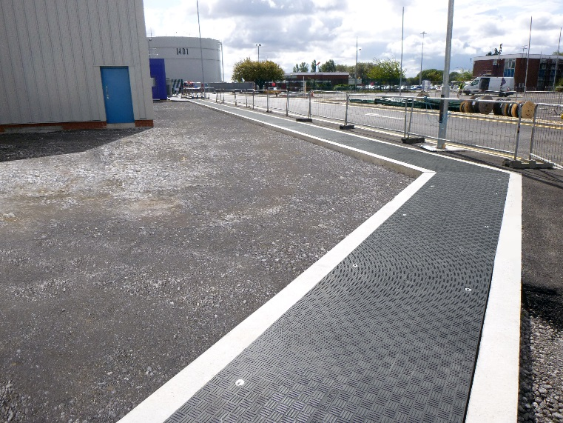
Risks are exacerbated if the covers become damaged, which concrete and metal are susceptible to when exposed to adverse weather, heavy traffic loads, high temperatures, or corrosive chemical materials.

The Benefits of Using GRP Composite Access Covers
In contrast to conventional covers, GRP composite access covers are drastically lighter (approx. 1/3), and if highly engineered (like Fibrelite’s), have a far longer lifespan, unaffected by adverse weather conditions, extreme temperatures and most chemicals.
Custom Fibrelite GRP trench covers were installed at Lindley Oil Refinery

Recent Project: Cadent Gas
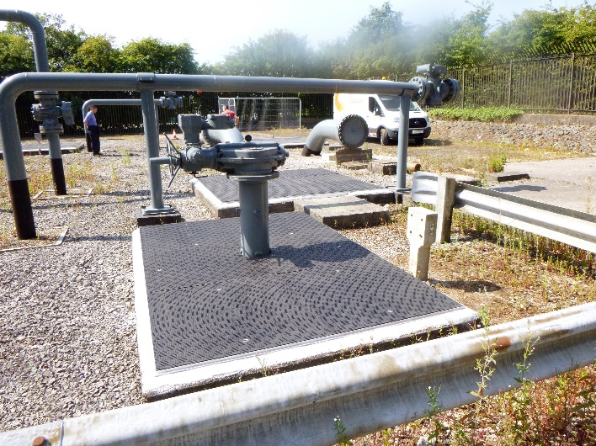
As part of Cadent Gas’ A61 upgrade in the North West of England, custom Fibrelite trench covers have been specified to replace previously installed heavy concrete recess covers at a number of sites, including the A61 in Warrington and Preston. Key requirements and reasons for upgrading included manual handling, longevity, technical support and custom sizes to fit existing arrangements.
Fibrelite’s covers installed at Cadent Gas site

Recent Project: Lindley Oil Refinery
As part of a complex large-scale renovation project at Lindley Oil Refinery (near Hull), custom Fibrelite composite trench covers were installed over steam pipes.
“This project came with its own unique challenges”, said Fibrelite Technical Director David Holmes. “We visited the site at critical points during the design and installation, engineering custom covers to fit the unusual trench dimensions within the tight delivery timelines (5 weeks). The corrosion resistance, anti-slip, and heat resistance unique to Fibrelite covers were also key for this installation.”
ENDS
Notes for Editor:
Full quality images available here
About Fibrelite
Fibrelite is a global manufacturer of highly-engineered glass reinforced plastic (GRP) composite access covers capable of taking up to 90 tonne loads whilst still being light enough to be lifted by hand and is renowned for its high quality technical support and service.

Initially developed almost 40 years ago and now industry standard for petrol station forecourts, Fibrelite covers are increasingly specified for both new and retrofit work in a variety of industries in more than 80 countries around the world. To find out more, please visit www.fibrelite.com.

For more information, please contact Aaron McConkey (aaron@fibrelite.com 01756 799773)
Fibrelite; Snaygill Industrial Estate; Keighley Road; Skipton; North Yorkshire BD23 2QR

