Fibrelite on Show at Big 5 Dubai with Partner Servetech
26-29th November 2018 | Dubai World Trade Centre | Stand 3A141

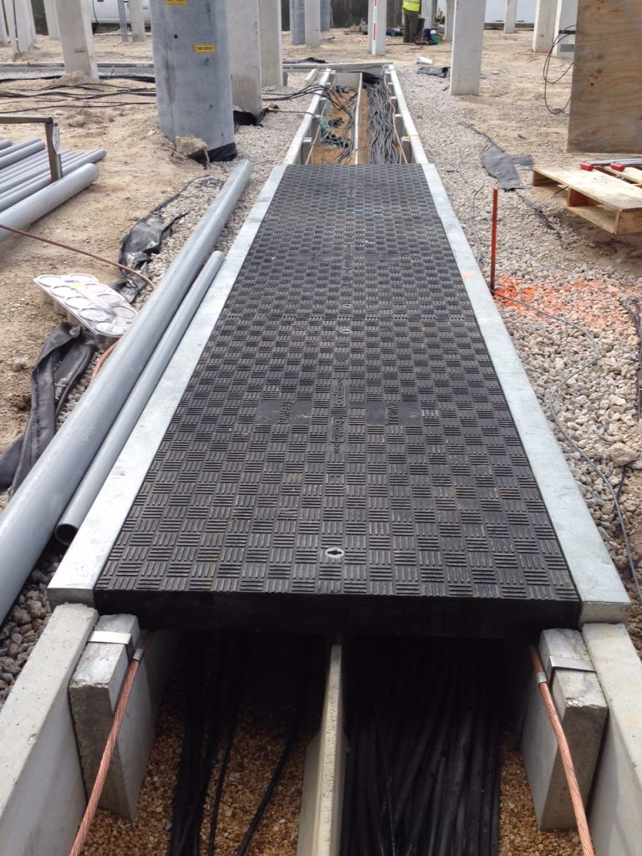
For the first time at this event Fibrelite will be introducing their covers specifically designed for precast concrete channels concrete trenches

Fibrelite’s partner Servetech are exhibiting at this year’s Big 5 exhibition in Dubai 26-29th November where they will be exhibiting a broad selection of products including Fibrelite GRP composite trench and manhole covers, designed and engineered to prevent manual handling injuries.
Trench Covers
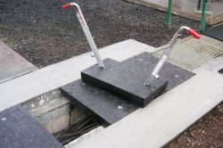
Fibrelite’s GRP trench covers are a high-performance product and a safer alternative to heavy metal and concrete, they are created via resin transfer moulding (RTM) to create a durable, monolithic cover that you can truly fit-and-forget. What’s more, each one has been individually engineered in Fibrelite’s own manufacturing facilities.
Fibrelite trench cover and FL7 lifting handles used for safe removal and replacement

Manhole Covers
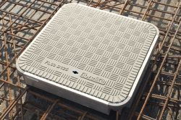
Lightweight for easy and safe manual removal, without compromising on strength. Fibrelite manhole covers are not only used on forecourts worldwide but are ideal for access to sewage systems, underground pipework, drainage networks, electrical junction boxes, water treatment plants and commercial fuel storage.
Fibrelite composite manhole cover

Precast Trenches
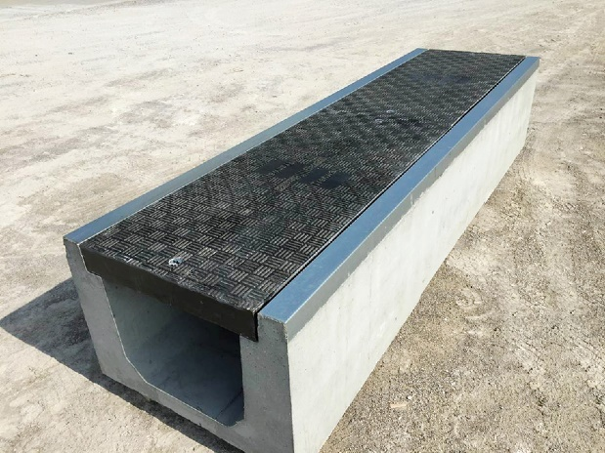
Precast concrete trench systems are used extensively in infrastructure to provide protection for and easy access to underground services. As specifications are changing to favour GRP access covers, Fibrelite is working with precast concrete trench manufacturers around the world to bring joint offerings to the market which offer superior safety, performance, durability and longevity.
Precast concrete trench systems including Fibrelite covers

Register here for free entry to the Big 5 and visit Fibrelite at the Servetech Stand 3A141 for a consultation with one of Fibrelite’s product experts.

ENDS
Notes for Editor:
Full quality images attached
About Fibrelite
Fibrelite is a global manufacturer of highly-engineered glass reinforced plastic (GRP) composite access covers capable of taking up to 90 tonne loads whilst still being light enough to be lifted by hand and is renowned for its high quality technical support and service.

Initially developed almost 40 years ago and now industry standard for petrol station forecourts, Fibrelite covers are increasingly specified for both new and retrofit work in a variety of industries in more than 80 countries around the world. To find out more, please visit www.fibrelite.com

About Big 5
The Big 5 gathers global construction expertise into one place for four days of research, discovery and real business. The event is a rare opportunity for you and other industry professionals to get face-to-face with a selection of experts with detailed knowledge about every aspect of the construction sector. To find out more, please visit https://www.thebig5.ae/

For more information, please contact Aaron McConkey (aaron@fibrelite.com +44 (0) 1756 799773)
Fibrelite; Snaygill Industrial Estate; Keighley Road; Skipton; North Yorkshire BD23 2QR

