Exhibiting and Nominated: OPW at APEA 2018
Stand D15 | 22nd November | Stadium MK | Milton Keynes, UK
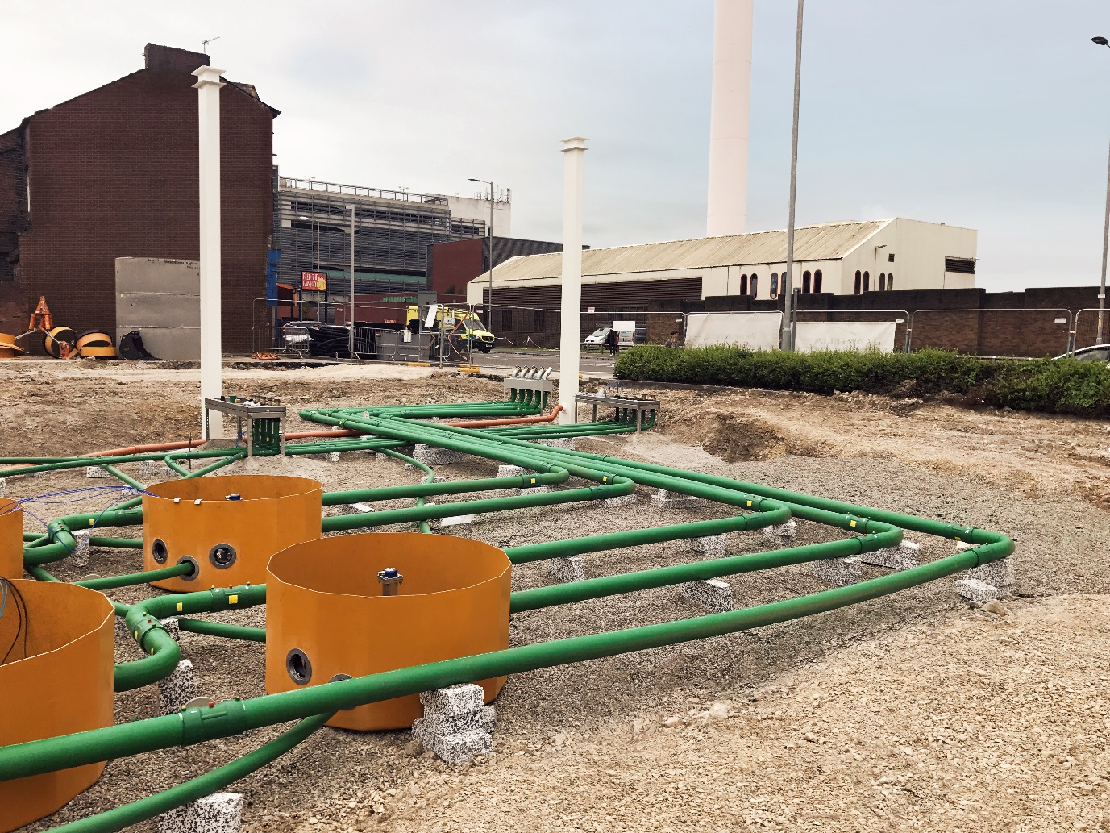
OPW’s Fibrelite sumps and KPS piping nominated for Environmental Protection and Improvement award
OPW (a global leader in fluid handling, management, monitoring and control solutions) is excited to announce that they will be exhibiting and have been nominated for two awards at this year’s APEA Live. A yearly event, it brings together the key people and companies in the UK retail fuelling industry.
Award Nominations
Environmental Protection and Improvement
Water ingress and fuel egress from sumps is a global problem on filling stations, causing safety and environmental issues. Fibrelite sumps offer the only truly liquid tight solution, which, combined with KPS piping (ATEX and IEC compliant) provides a sustainable solution ensuring complete containment for the lifecycle of the site.
Best New Non-Retail Fuel Installation
While retail fuelling is OPW’s primary focus, they are often approached to apply their expertise to non-retail fuel installations. This nomination shows one such project, a new build thermal power plant on Saint-Pierre, Réunion island (near Madagascar) with a bi-fuel turbine (diesel and ethanol). OPW worked with the company to provide a safe solution using Fibrelite sumps and KPS piping.
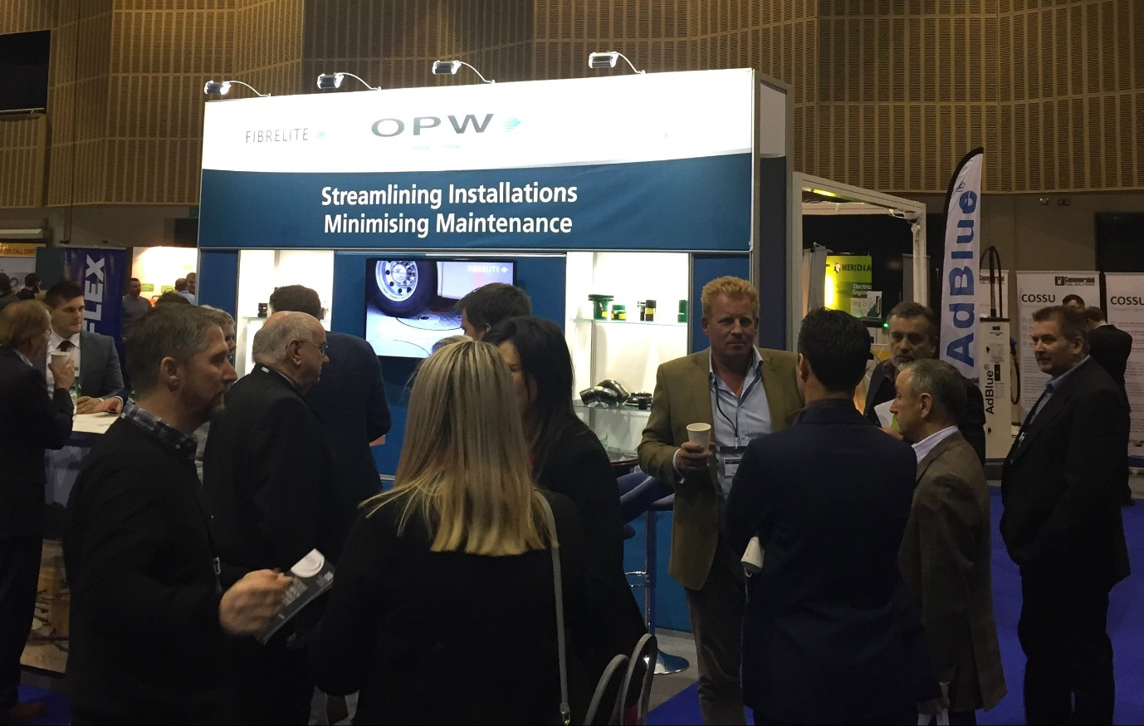
APEA Live brings together the key people and companies in the UK retail fuelling industry
On Show – Stand D15
Visit the OPW team to learn about their unprecedented portfolio of complementary best in class retail fuelling products designed to solve client’s current and future challenges. Products on show will include KPS piping and a Fibrelite remote fill sump.
OPW looks forward to seeing you there. Register free here
For more information visit the OPW website
ENDS
Notes for Editor:
Full quality images attached
About OPW
​OPW is a global leader in fluid handling, management, monitoring and control solutions for the safe and efficient handling of fluids from the refinery to the commercial and retail points of consumption, including loading systems, rail and transport tank truck equipment, tank gauging, fuel management systems, valves, fittings, underground and above ground storage tank equipment, spill containers, overfill prevention devices, secondary containment sumps and flexible piping, commercial and retail fuelling dispensers and electronic POS systems, swivels, breakaways, and nozzles for virtually all fuel types, including LPG, Hydrogen and CNG. OPW also designs and manufactures touch-free and friction car wash systems. OPW has 3,850+ employees with manufacturing operations in North America, Europe, Brazil, China and India and sales around the world.
For more information please contact: Aaron McConkey (aaron.mcconkey@opwglobal.com and +44 (0) 1756 799 773)

